**r feedback in software**

**ACÁ VA EL NOMBRE DEL DOCUMENTO**

Acá puede ir una descripción breve o información adicional sobre el documento.

**Worksheet 11.1**

**New vocabulary:**

**Write a synonym or the translation next to each world.**

Feedback

•user

•complaint

•improve

•features

•try

•developers

•test cases

•useful

•updates

•team

•bugs

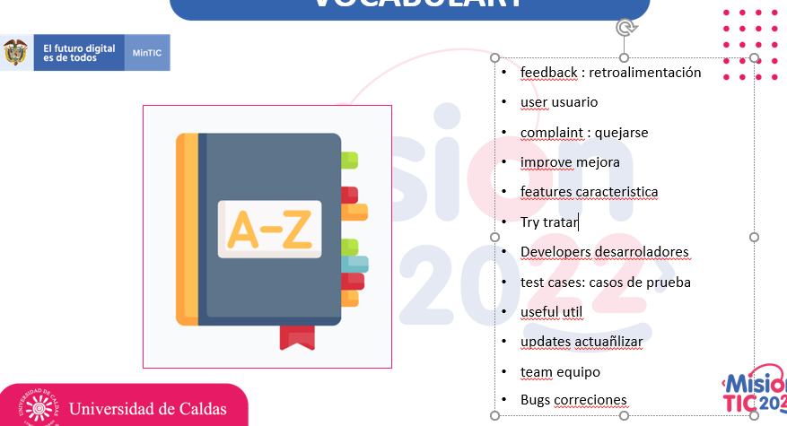

<https://wordwall.net/resource/17390459/find-the-match-new-vocabulary-activity>

<https://www.educaplay.com/learning-resources/9564434-vocabulary_session_11.html>

**Use the words you found in short sentences, there is an example.**

Our boss gave us good feedback.

**The users of the technology _____**

**Algorithms are useful____________**

**Development team at work_______**

**Features of a person ____________**

**Extra activity: Find the vocabulary words in the following word search.**

[**https://thewordsearch.com/puzzle/2482439/vocabulary-session-11/**](https://thewordsearch.com/puzzle/2482439/vocabulary-session-11/)

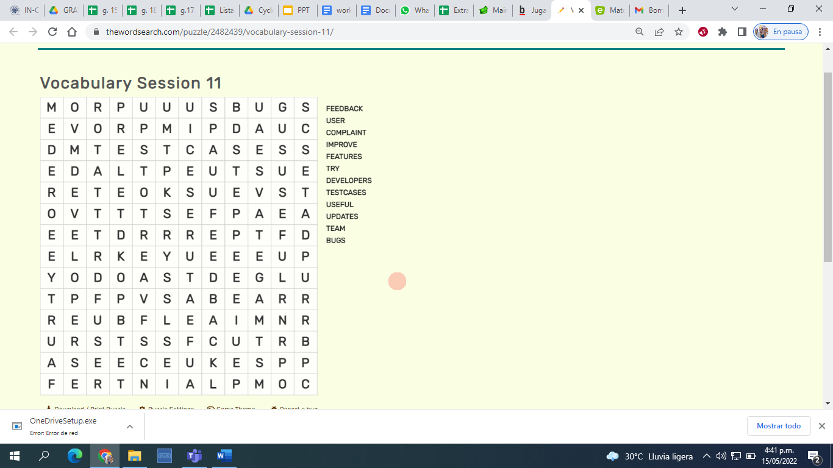

**Worksheet 11.2**

**Practice the Reading strategy “looking for main ideas” by doing the following Steps:**

* First, you have 1 minute to read only the parts of the text that are highlighted with yellow.
* After reading the text that is highlighted with yellow. Please answer “Main Ideas Comprehension” questions.
* Finally, read the whole text and answer the questions in the Evaluation section.

**User Feedback in Software Development**

**Feedback** is a very important component in any work. Feedback helps you clarify your understanding. Feedback helps you see things in new ways. Feedback helps you correct your course. Feedback helps you learn.  Feedback makes you and your work better.

Introduction

Software is created to satisfy **user**’s requirements. A software is good if the majority of the users have no **complaint** about it after using for a long time. As a consequence, more and more attention today is paid to user feedback. Software companies want to know what their users really think of their products, which aspect they consider important, what functions they expect, etc. They want to learn as much as possible from their users to **improve** their product quality.

Particular Characteristics of User Feedback in Software Development

User feedback is important to all types of product development, and software is no exception. However, different to others, software development has its own **features** that make user feedback different.

First, in software development it is impossible to predict all the problems in advance. The only way the developer can know if the software works or not is by letting users **try** them. Although the **developers** can write some **test cases**, those test cases are created from the point of view of the developers and not from the point of view of the users.  Only when developers receive feedback from the users can they really know what’s wrong.

Second, even only one user's feedback can be **useful** for software development. Of course, the more users give feedback, the better for the developers, but sometimes even one comment can help improve the product.

Additionally, **updates** are necessary in software development, especially for mobile applications. If an application stops updating for several months or even several weeks, people will use other applications with similar functions instead. Logically, the updates take into account the information from the user feedback.

Finally, it is widely accepted that positive user feedback will make the development **team** much more confident. So user feedback is not only about negative comments and reports of **bugs**, it is also about good things that people like about programs and applications.

Conclusion

The quality of the product is always the most important thing during software development. No matter how well we know our users, if we cannot satisfy their requirements, our work means nothing. In software development, it is impossible to predict all the problems before people start using the program/application. Remember that negative feedback is better than no feedback. Any information can be useful, it just depends on how we use it.

**Main Ideas Comprehension**

Have the students read the following statements and select the correct option.

1. User feedback **helps**/**doesn't help** you make the product better.
2. User's requirements are **essential**/**irrelevant** in software development.
3. Software developers **can**/**cannot** predict all the possible bugs in advance.
4. One user's feedback **is**/**is not** useful in software development.
5. Positive feedback makes the **users**/**developers** feel happy.

**Worksheet 11.3**

**Categorize the following ideas from the text into “Main” and “Secondary”.**

1. Feedback helps you correct your course, it helps you learn, finally, it makes you and your work better.

2. Feedback is a very important component in any work**.**

1. A software is good if the majority of the users have no complaint about it after using for a long time.

2. Software is created to satisfy user’s requirements.

1. Software development has its own features that make user feedback different.

2. First, in software development it is impossible to predict all the problems in advance. The only way the developer can know if the software works or not is by letting users try them.

1. If an application stops updating for several months or even several weeks, people will use other applications with similar functions instead.

2. Updates are necessary in software development, especially for mobile applications.

**Worksheet 11.4**

**Answer the following questions:**

1. Entiendo qué es “user feedback” y por qué es importante.  
   Si No Tal vez
2. Entiendo cómo utilizar la estrategia de “Looking for main ideas”.  
   Si No Tal vez
3. La estrategia “Looking for main ideas” me ayuda a entender la idea general de un texto.  
   Si No Tal vez
4. Entiendo la diferencia entre las ideas principales y las ideas secundarias.  
   Si No Tal vez